- Jump to main content
- nature.com homepage
- Publications A-Z index

Top of Form
Search Advanced search
Bottom of Form

Journal home > Archive > Original Articles > Full text > Figure 3

FIGURE 3
FROM:

Birt-Hogg-Dubé Syndrome: Clinical and Genetic Studies of 20 Families
Edward M Leter, A Karijn Koopmans, Johan J P Gille, Theo A M van Os, Gabriëlle G Vittoz, Eric F L David, Elisabeth H Jaspars, Pieter E Postmus, R Jeroen A van Moorselaar, Mikael E Craanen, Theo M Starink and Fred H Menko
BACK TO ARTICLE

Figure 3.
Previous figure | Figure and tables index
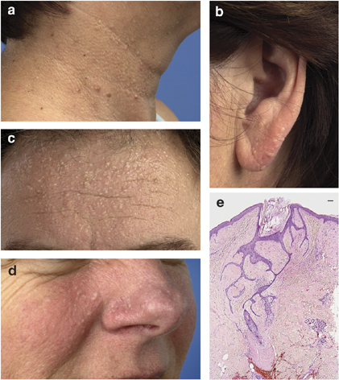
Skin manifestations in four BHD patients. Multiple small skin-colored papules clinically compatible with fibrofolliculomas or trichodiscomas (a) in the neck area and (b) on the ear of patient III-12 from family 1, (c) on the forehead of patient III-3 from family 2, and (d) on the nose and paranasal area of patient IV-6 from family 8. (e) Biopsy of one of the papules of the proband from family 13 shows the characteristic histological picture of a fibrofolliculoma. The hair follicle is dilated, its basal layer forms fine anastomosing strands of basaloid cells and is surrounded by a sharply demarcated layer of fibromucinous stroma. Bar=250 m.

